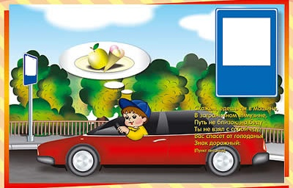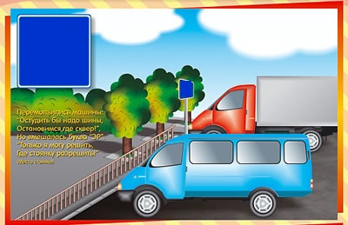

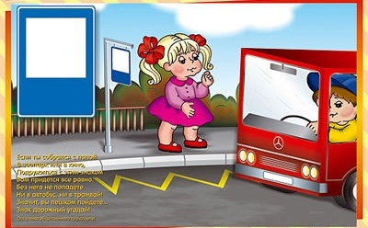

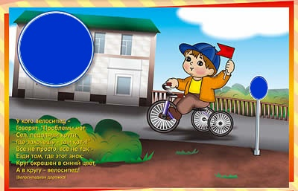

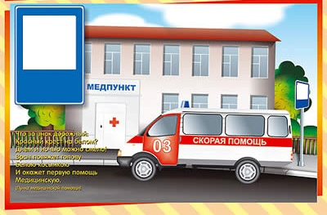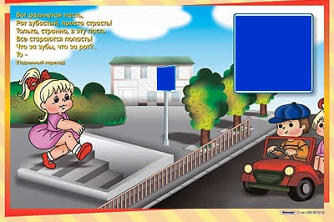 

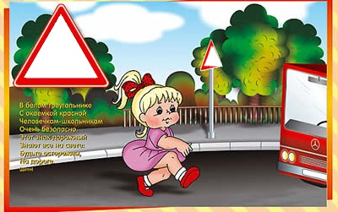

|  |  |  |
| --- | --- | --- |
|  | C:\Users\User\Desktop\ЦОР 2010Г\материал\Graphic002.gif |  |
| C:\Users\User\Desktop\ЦОР 2010Г\материал\Graphic017.gif | C:\Users\User\Desktop\ЦОР 2010Г\материал\informacionie_005_big.gif | C:\Users\User\Desktop\ЦОР 2010Г\материал\ukazateli_032_big.gif |
| C:\Users\User\Desktop\ЦОР 2010Г\материал\informacionie_007_big.gif |  |  |